BARS Job Aid

- Log into BARS at https://apps.beckman.illinois.edu/BARS/.
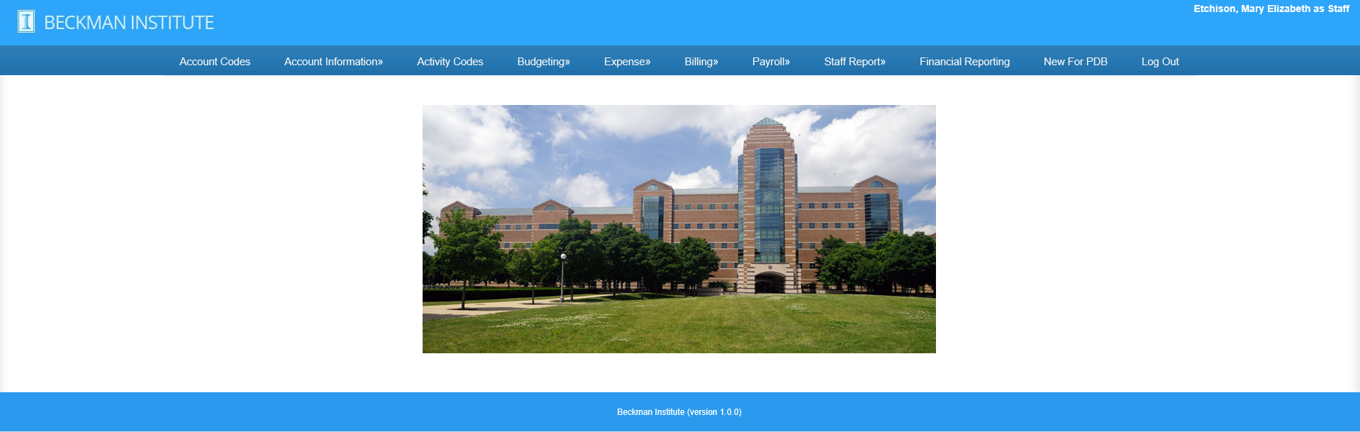
- Click on Financial Reporting to see all active (A) funds associated with you divided into 3 categories:
- Non-Grants (State, ICR, Gift, and Plant) CFOP Accounts
- Grants CFOP Accounts (including Cost Share)
- Revenue (Self-Supporting) CFOP Accounts

To see accounts that are inactive (frozen-F and deleted-D), click on “show all” in the appropriate account reporting section.
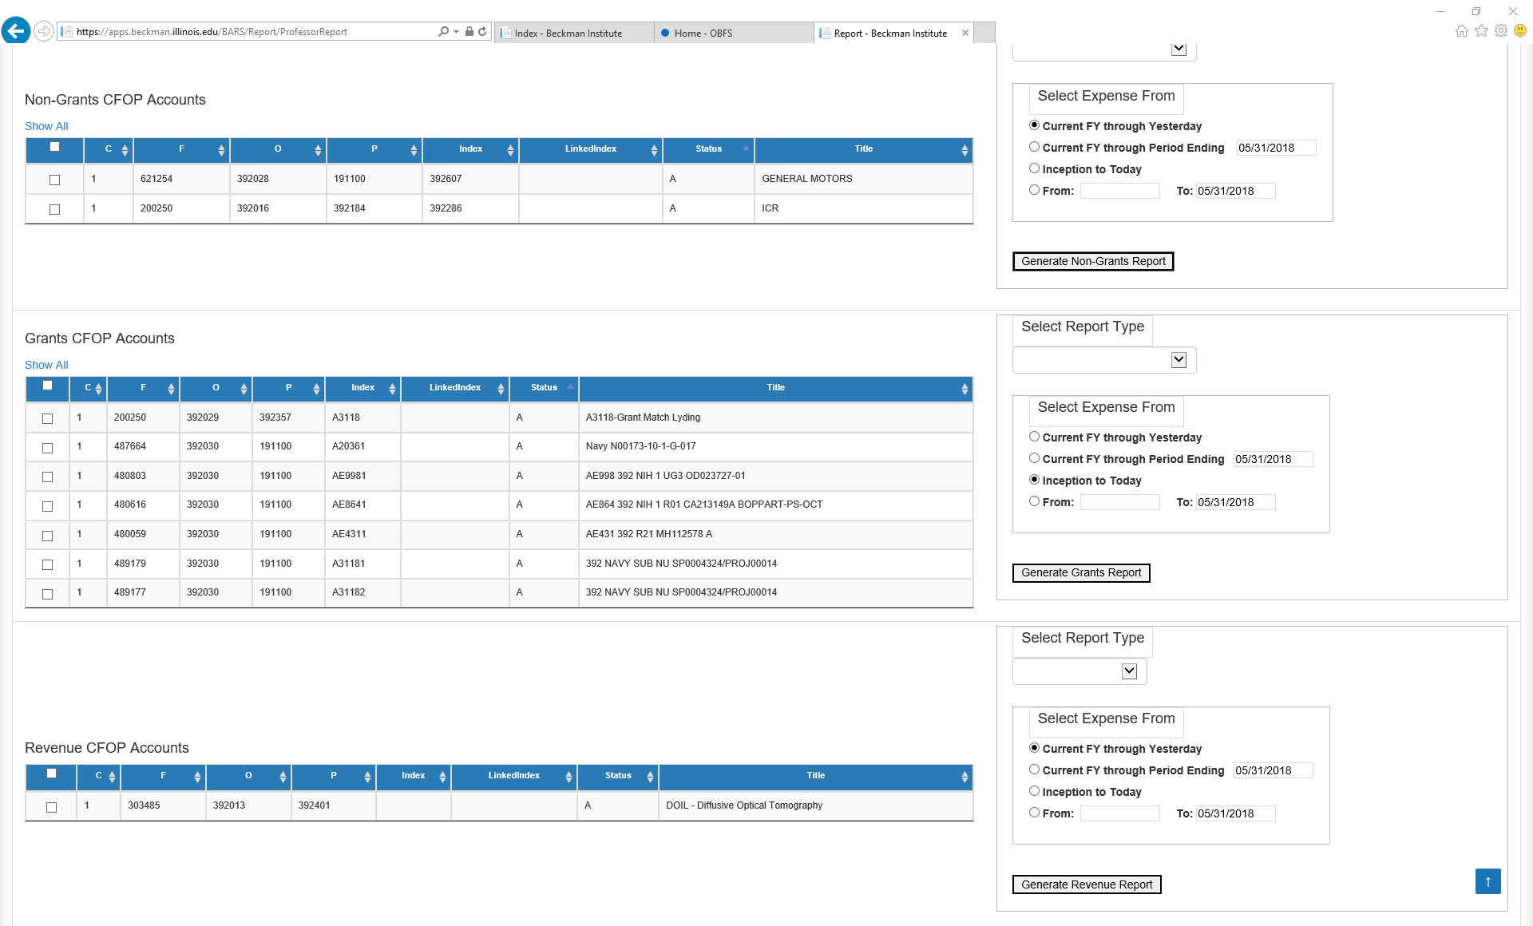
- Sort accounts (by Chart, Fund, Org, Program Code, etc.) by clicking on the arrows in the column headings.

Select accounts by clicking in the boxes on the left, or click in the box in the blue-shaded area to select all accounts in the category.

Choose the report type and desired time frame.
Non-Grants (State, ICR, Gift, and Plant) CFOP Accounts
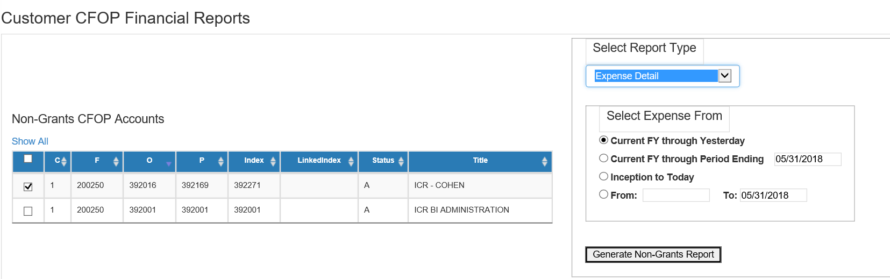
Select Report Type
Click on the drop-down arrow and select a report.
- Expense Detail: Includes all details for expenses and obligations and the total for each account code.
- Expense Summary: Shows totals for budget, expense, and obligation categories.
- Balance Summary: Shows totals for budget, expenses, and obligations including the most recent month and year-to-date amounts.
- Balance Summary and Detail: Creates Balance Summary and Expense Detail Reports. (This report most closely mirrors the financial statements you previously received.)
Select Time Period
Choose the time period, changing dates in boxes as needed to get desired result.
To run a report for a previous fiscal year, please choose “FY Through Period Ending [Date]”, and enter 6/30/202X.
Create Report
After all selections have been made, click on Generate Non-Grants Report. Use the icons across the top of the page to go to another fund and to save (as Excel, PDF, or Word) or to print reports.

Grant CFOP Accounts

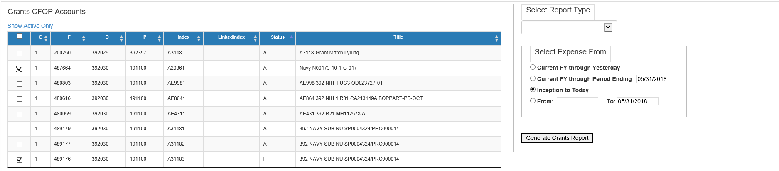

Select Report Type
Click on the drop-down arrow and select a report.
- Expense Detail: Details of all expenses and obligations in the selected time frame.
- Expense Summary: Expenses grouped by major expense category in selected time frame.
- Balance Summary: Inception to date summary of budget vs. expenses and obligations for current month and inception to date and balance of each budget category.
- Balance Summary and Detail: Balance summary plus details of all expenses. (This report most closely mirrors the financial statements you previously received.)
- Linked Balance Summary: Summary of all funds linked to a specific grant code (including grant match) followed by break down of each associated fund.
Select Time Period
Choose the reporting period adding dates as necessary to filter results.
Create Report
After all selections have been made, click on Generate Grants Report. Use the icons across the top of the page to go to another fund and to save (as Excel, PDF, or Word) or to print reports.
Reports will open in a new window with a separate page for each fund selected.

Revenue (Self-Supporting) CFOP Accounts
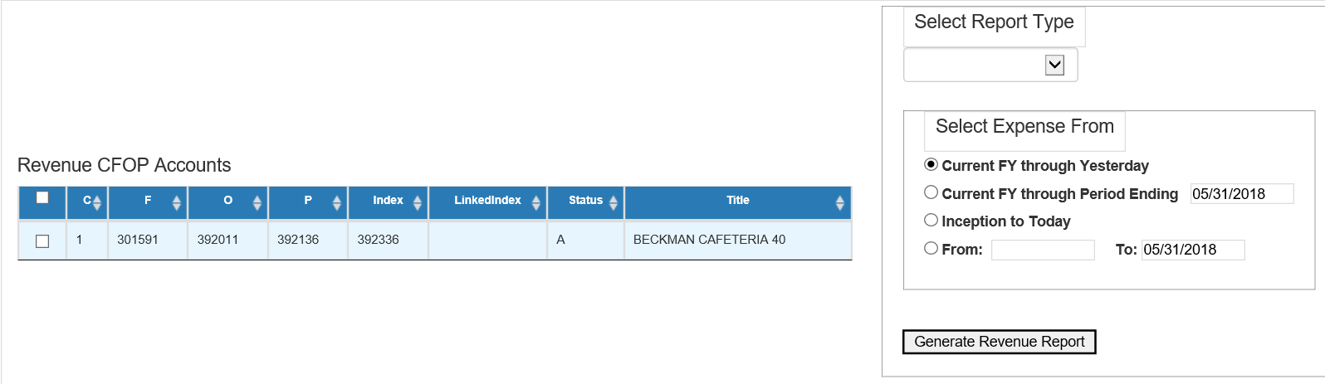
Select Report Type
Click on the drop-down arrow and select a report.
- Expense Detail: Includes all details for expenses and obligations and the total for each account code.
- Revenue Summary: Includes monthly totals for revenue, expenses, and obligations.
Select Time Period
Choose the time period, changing dates in boxes as needed to get desired result.
To run a report for a previous fiscal year, please choose “FY Through Period Ending [Date]”, and enter 6/30/202X.
Create Report
After all selections have been made, click on Generate Revenue Report. Use the icons across the top of the page to go to another fund and to save or print reports.

